**Python Security(ST2414)**

**Created by: Hong Wei**

**Hangman Game**

**Class: DISM/FT/1B/08**

Table of contents

Flowchart and explanation for Hangman game ------------------------------- 3 - 7

Flowchart and explanation for Hangman admin ---------------------------- 8 - 13

**Readme.txt guide is available for proper setup of the program**

**Flowchart for Hangman drawn with Draw.io**

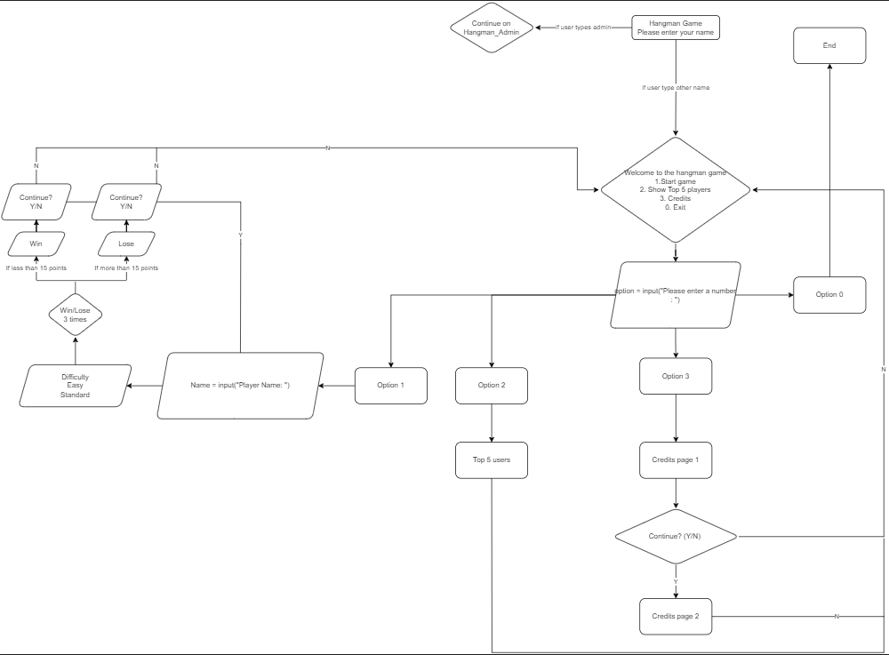

All settings can be configured in the gamesettings.txt file

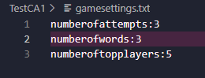

**Client side:**

It starts off with asking for your name



If you don’t key in a name



If you type in a name, you will go into the main menu

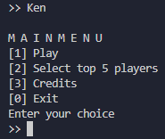

If you type anything other than 0 to 3, it will return an error

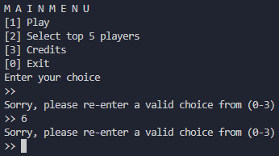

Option number 1 allows the user to play the game

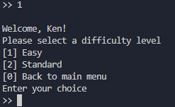

Press 1 for easy difficulty (10 tries) and 2 for standard difficulty (5 tries)

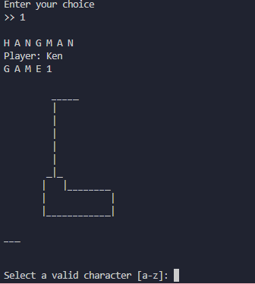

Even if the user types in capital letters, it will be accepted

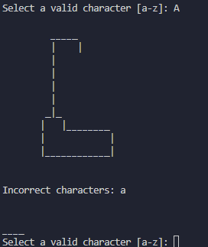

If the user types in nothing or types in 2 characters at once, the program will output this error

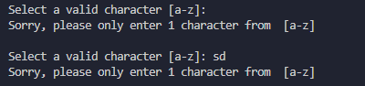

If the user types in a integer instead of a letter, the program will give a error message



Whether you get it right or not it will print the word and the definition of the word

Correct output:



Incorrect output:



After 3 tries, regardless of being able to guess the words or not, the game will end and let you know that you have set a new high score if you are new or you have beaten your previous record

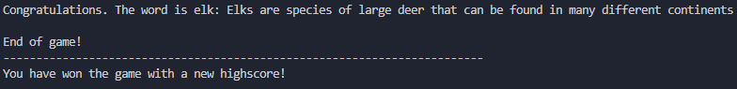

Option number 2 allows the user to view the top 5 positions

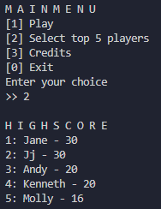

Option number 2 allows the user to view the credits

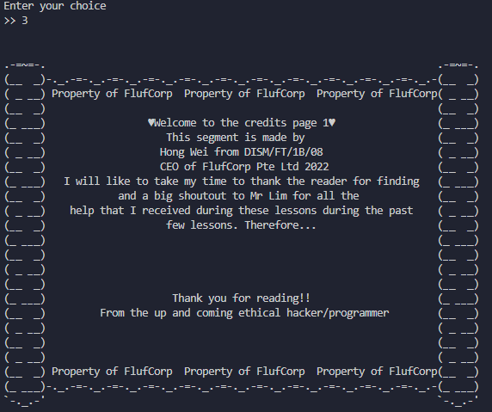

Finally option number 0 allows the user exit the program

**Admin side:**

It starts off with asking for your name



To access the admin menu, type in username Admin and password qQ1@(default)

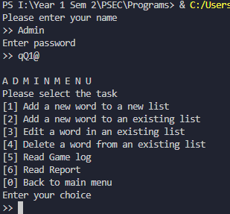

Option number 1 allows the admin to append new word in new wordlist



Output if wordlist name is empty

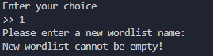

Output if new word is empty

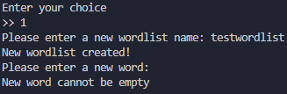

Output if new definition is empty

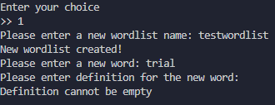

Final output of function

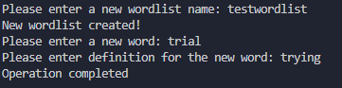

Option number 2 allows the admin to append new word in existing wordlist



Output if wordlist does not exist or is empty



Output if new word is empty

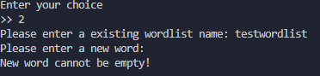

Output if word already exists



Output if new definition is empty



Final output of function

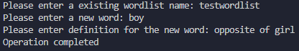

Option number 3 allows the admin to edit existing word definition in existing wordlist



Output if word list is empty or doesn’t exist

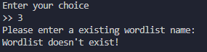

Output if existing word is empty

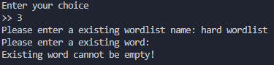

Output if word doesn’t exists

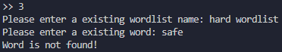

Output if word definition is empty

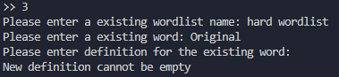

Final output of function

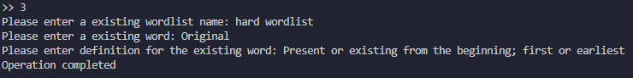

Option number 4 allows the admin to delete existing word in existing wordlist



Output if word list is empty or doesn’t exist



Output if existing word is empty

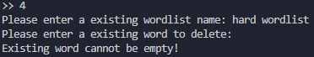

Output if word doesn’t exist

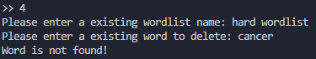

Final output of function

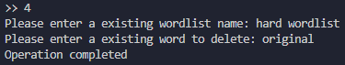

Option number 5 allows the admin to read the game report

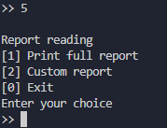

If admin types sub-option 1, the program will print the full report to the admin

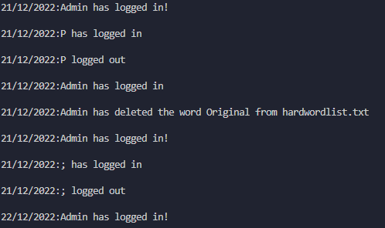

If admin types sub-option 2, the program will ask the user to specify start to end and display the earliest and the latest log that have been captured.

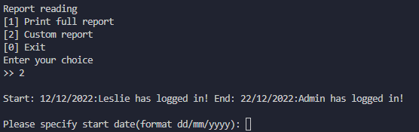

Final output of function

Option number 6 allows the admin to edit game settings

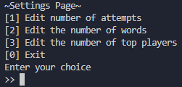

For choice 1, if the input is blank, said setting will default to original number





If you type in a number the settings will change from default 3 to 5



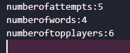

For choice 2, if the input is blank, said setting will default to original number





If you type in a number the settings will change from default 3 to 7





For choice 3 if the input is blank, said setting will default to original number





If you type in a number the settings will change from default 5 to 9





Flowchart for Hangman admin drawn with Draw.io

